Name:………………………………………………..…. Date:………………………………………………………
Crystal chemistry
The body beautiful: protein crystals
Experiment and investigation
Protein is not just something to eat! Proteins are biological polymers. A polymer is a large molecule made when small molecules (usually called monomers) are bonded together. Nylon and poly(ethene) are examples of non-biological polymers. The small molecules in proteins are called amino acids. There are 20 different amino acids in nature. The type and order of amino acids are controlled by a piece of DNA called a gene. The 'code' on the gene tells a cell the amino acids needed to make a protein. One gene codes for one protein. There are as many proteins as there are genes - and that is a lot of different proteins! Each protein has a part to play in making an organism work correctly. Scientists want to know much more about the structure of proteins and how they work. Making protein crystals is a good start.
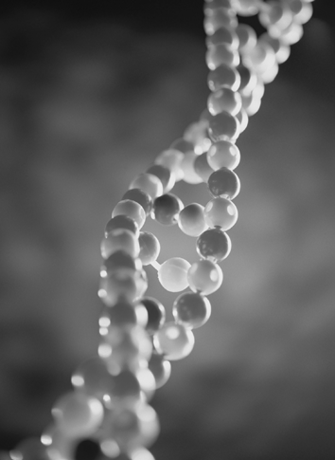 | 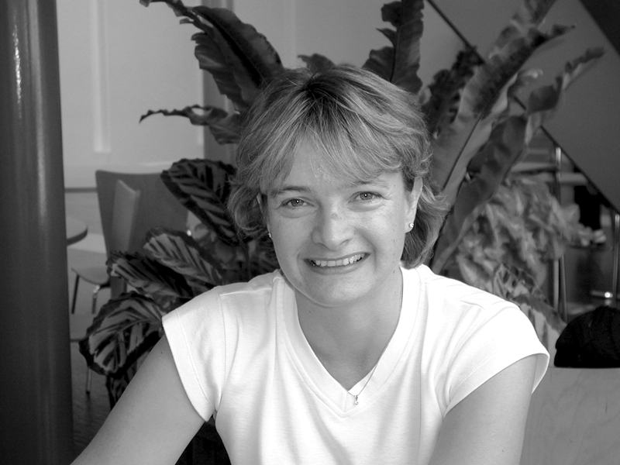
Julia Walton
Reproduced with kind permission of Julia Walton of York, UK.
Growing protein crystals
Proteins are found in many different places in the body. For example, the protein called collagen is found in our skin, hair and nails – small differences in the amino acid chains give us curly or straight hair, make our skin stretchy and nails tough. Other proteins make sure that all the chemical reactions in the body happen quickly enough for us to live. These proteins are called enzymes. Proteins also help chemicals such as hormones get into cells. These are often called receptors because they receive the hormone molecules. Drug companies and scientists researching illnesses such as cancer want to know what proteins look like to help develop good drugs and treatments. Find out more about the starting point for this – growing protein crystals.
What you do
Read the interview with protein scientist Julia Walton then answer the questions.
Growing protein crystals: An interview with Julia Walton
Julia Walton works in the Structural Biology Laboratory in the Chemistry Department at the University of York.
continued on next page



Crystal chemistry
continued from previous page

Profile: Julia studied chemistry, physics and maths at A level. She then completed a degree in chemistry and biochemistry at the University of Nottingham in the UK. Julia has worked in protein purification for a number of years, including spending time at the chemical company called Bayer in California, USA. Julia joined the Chemistry Department at York in 1995 where she grows protein crystals for other scientists' experiments.
Q. Why are protein crystals needed?
Julia: You have to grow protein crystals because only a crystal can be investigated by X-ray crystallography. This is used to solve the three dimensional structure of the molecule. This gives a model for the protein and enables drug companies to target drugs and helps biochemists to find out how the proteins work in the body.
Q. Why do proteins make crystals?
Julia: They are like any other molecules. When you change the solubility slowly the molecules line up in a regular lattice. All the protein molecules in one crystal are the same, so the crystal has a regular structure.
Q. Describe how you grow protein crystals.
Julia: We use very tiny amounts of protein solutions. I make a tiny drop of about 1 µl (0.001 cm³) then add substances that slowly make the protein precipitate. These are salts and chemicals called polyethylene glycols (PEGs). The mixture will vary depending on the protein. The drop is hung over a solution. The drop is more dilute than the solution underneath. So gradually, the system reaches equilibrium as water leaves the drop and goes to the solution. As the water leaves, the salts and PEGs change the solubility of the protein and help the crystal to form.
Q. How long does it take to grow a protein crystal?
Julia: That depends on the protein! Anything from 10 minutes to a year. Lysozyme, for example, is an enzyme found in tear fluid. It takes 10 minutes to grow lysozyme crystals. A new protein may take a year because I have to work out the best conditions for growing crystals.
Q. What size is a finished crystal?
Julia: The finished crystals are less than 1 mm across. Sometimes we get one which can be seen with the naked eye – we think of this as enormous! Most of the time they are about
0.1 – 0.5 mm and can only be seen with a microscope.
Q. What shapes do protein crystals have?
Julia: The crystals have rounded shapes. Sometimes they look rod-shaped. They look like gemstones – hexagonal rods and prisms for example.
continued on next page

Crystal chemistry
continued from previous page

Q. Why are their shapes so different from substances like salt?
Julia: Each protein is a very long polymer. These fold up in specific ways depending on the amino acids in the chain. Salt is a simple compound made from two chemical elements, so its crystalline structure will be very different from a protein crystal.
Q. Give an example of a protein you have crystallised.
Julia: I have crystallised the oestrogen receptor. This is a protein found on the surface of cell nuclei. The receptor binds the hormone oestrogen from the blood. When oestrogen is bound to the receptor this causes a change in the DNA made in the nucleus.
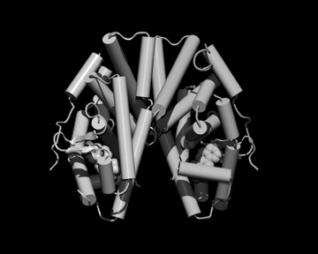
Oestrogen receptor
Reproduced with kind permission of Professor R E Hubbard, Department of Chemistry, University of York, UK.

Q. What does this protein do in the body?
Julia: Breast, ovaries and bone tissue have lots of oestrogen receptors. These tissues need a supply of oestrogen. If this supply goes wrong, these tissues cannot function properly. Knowing how the hormone and the oestrogen receptor work together helps biochemists understand why the system sometimes does not work.
Q. What happens to the protein crystals after you have grown them?
Julia: They are frozen in liquid nitrogen and then someone does X-ray crystallography on them. Then they are thrown away.
Q. Why must protein crystals be so pure and perfect?
Julia: If the protein solution is not pure we will not get crystals. Also a perfectly formed crystal is needed for X-ray crystallography.
continued on next page

Crystal chemistry
continued from previous page

Q. Describe what you like about your job.
Julia: It is very satisfying when I get good crystals and then to see the picture showing the structure. X-ray crystallography is a big area of science in which it is rewarding to see the results. Also, the results are used by drug companies to make treatments for cancer prevention so I feel I am making a contribution to this. The science is very precise and I have to be very accurate.
Questions
1. In what ways are the methods for growing a salt and protein crystals similar?
……………………………………………………………………………………………………………….……………………………………………………………………………………………………………….……………………………………………………………………………………………………………….……………………………………………………………………………………………………………….
2. In what ways are the methods different?
……………………………………………………………………………………………………………….……………………………………………………………………………………………………………….……………………………………………………………………………………………………………….……………………………………………………………………………………………………………….
3. Why do the sizes and shapes of the protein crystals vary?
……………………………………………………………………………………………………………….……………………………………………………………………………………………………………….……………………………………………………………………………………………………………….……………………………………………………………………………………………………………….4. What sort of tests might Julia do to work out the best conditions for growing a new protein crystal?
……………………………………………………………………………………………………………….……………………………………………………………………………………………………………….……………………………………………………………………………………………………………….……………………………………………………………………………………………………………….
5. Why do proteins make good crystals?
……………………………………………………………………………………………………………….……………………………………………………………………………………………………………….……………………………………………………………………………………………………………….……………………………………………………………………………………………………………….
continued on next page

Crystal chemistry
continued from previous page

6. Why is growing protein crystals an important part of science today?
……………………………………………………………………………………………………………….……………………………………………………………………………………………………………….……………………………………………………………………………………………………………….……………………………………………………………………………………………………………….

